Experiment Number : 06 Date: 05.02.2026

ABSTRACT CLASSES
Aim:
To understand and implement inheritance concepts in Java.
PRE LAB EXERCISE
QUESTIONS
- What is an abstract class?
An abstract class is a class that cannot be instantiated and may contain abstract methods (methods without a body).
It is used as a base class for other classes.
- Why are abstract methods used?
Abstract methods are used to force child classes to provide their own implementation.
They help achieve polymorphism and provide a common structure for all subclasses.
- Difference between abstract class and interface.
An abstract class can have both abstract and concrete methods, while an interface mainly contains abstract methods (with default/static methods allowed from Java 8). Abstract classes can have variables with any access level, but interface variables are always public, static, and final. Abstract classes support single inheritance, whereas interfaces allow multiple inheritance. In simple terms, abstract classes define common structure, and interfaces define common behavior.
IN LAB EXERCISE
Objective:
To implement abstract class and demonstrate abstraction.
PROGRAMS:
1.University System
Scenario:
A university has different types of courses: Online, Offline, and Hybrid. Each course has a getDetails() method.
Question:
Create an abstract class Course with abstract method getDetails(). Implement OnlineCourse, OfflineCourse, and HybridCourse classes.
Code:
abstract class Course {
abstract void getDetails();
}

class OnlineCourse extends Course {
void getDetails() {
System.out.println("Online Course: Attend via Internet");
}
}

class OfflineCourse extends Course {
void getDetails() {
System.out.println("Offline Course: Attend in classroom");
}
}

class HybridCourse extends Course {
void getDetails() {
System.out.println("Hybrid Course: Combination of online and offline");
}
}

public class Main {
public static void main(String[] args) {
Course c1 = new OnlineCourse();
Course c2 = new OfflineCourse();
Course c3 = new HybridCourse();

c1.getDetails();
c2.getDetails();
c3.getDetails();
}
}
Output:
Online Course: Attend via Internet
Offline Course: Attend in classroom
Hybrid Course: Combination of online and offline
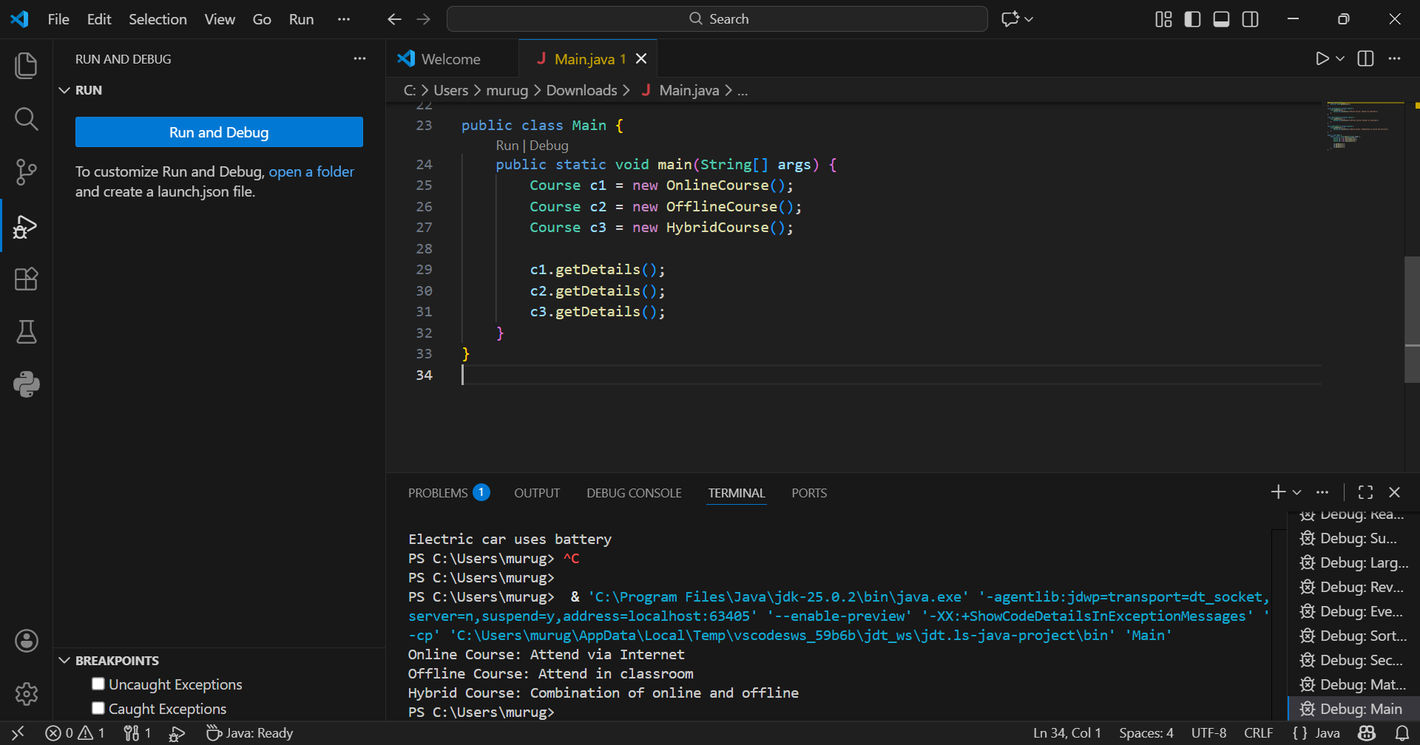
2. Employee Payroll System
Scenario:
A company has different types of employees — Regular and Contract. All employees have a salary, but the calculation differs for each type.
Question:
Design an abstract class Employee with an abstract method calculateSalary(). Implement subclasses RegularEmployee and ContractEmployee to calculate salary differently.
Code:
import java.util.Scanner;
abstract class Employee {
String name;
double baseSalary;

// Abstract method to calculate total salary
abstract void calculateSalary();
}

class RegularEmployee extends Employee {
double bonusRate = 0.1; // 10% bonus

void calculateSalary() {
double totalSalary = baseSalary + (baseSalary * bonusRate);
System.out.println("Regular Employee: " + name);
System.out.println("Base Salary: " + baseSalary);
System.out.println("Total Salary (with 10% bonus): " + totalSalary);
}
}

class ContractEmployee extends Employee {
void calculateSalary() {
System.out.println("Contract Employee: " + name);
System.out.println("Total Salary: " + baseSalary);
}
}

public class Main {
public static void main(String[] args) {
Scanner sc = new Scanner(System.in);

// Input for Regular Employee
System.out.print("Enter Regular Employee Name: ");
String regName = sc.nextLine();
System.out.print("Enter Base Salary: ");
double regSalary = sc.nextDouble();
sc.nextLine(); // Consume newline

// Input for Contract Employee
System.out.print("Enter Contract Employee Name: ");
String conName = sc.nextLine();
System.out.print("Enter Base Salary: ");
double conSalary = sc.nextDouble();

// Create objects
Employee e1 = new RegularEmployee();
e1.name = regName;
e1.baseSalary = regSalary;

Employee e2 = new ContractEmployee();
e2.name = conName;
e2.baseSalary = conSalary;

System.out.println("\n--- Salary Details ---");
e1.calculateSalary();
System.out.println();
e2.calculateSalary();

sc.close();
}
}
Output:
Enter Regular Employee Name: Ram
Enter Base Salary: 30000
Enter Contract Employee Name: Ravi
Enter Base Salary: 20000

--- Salary Details ---
Regular Employee: Anitha
Base Salary: 30000.0
Total Salary (with 10% bonus): 33000.0

Contract Employee: Ravi
Total Salary: 20000.0
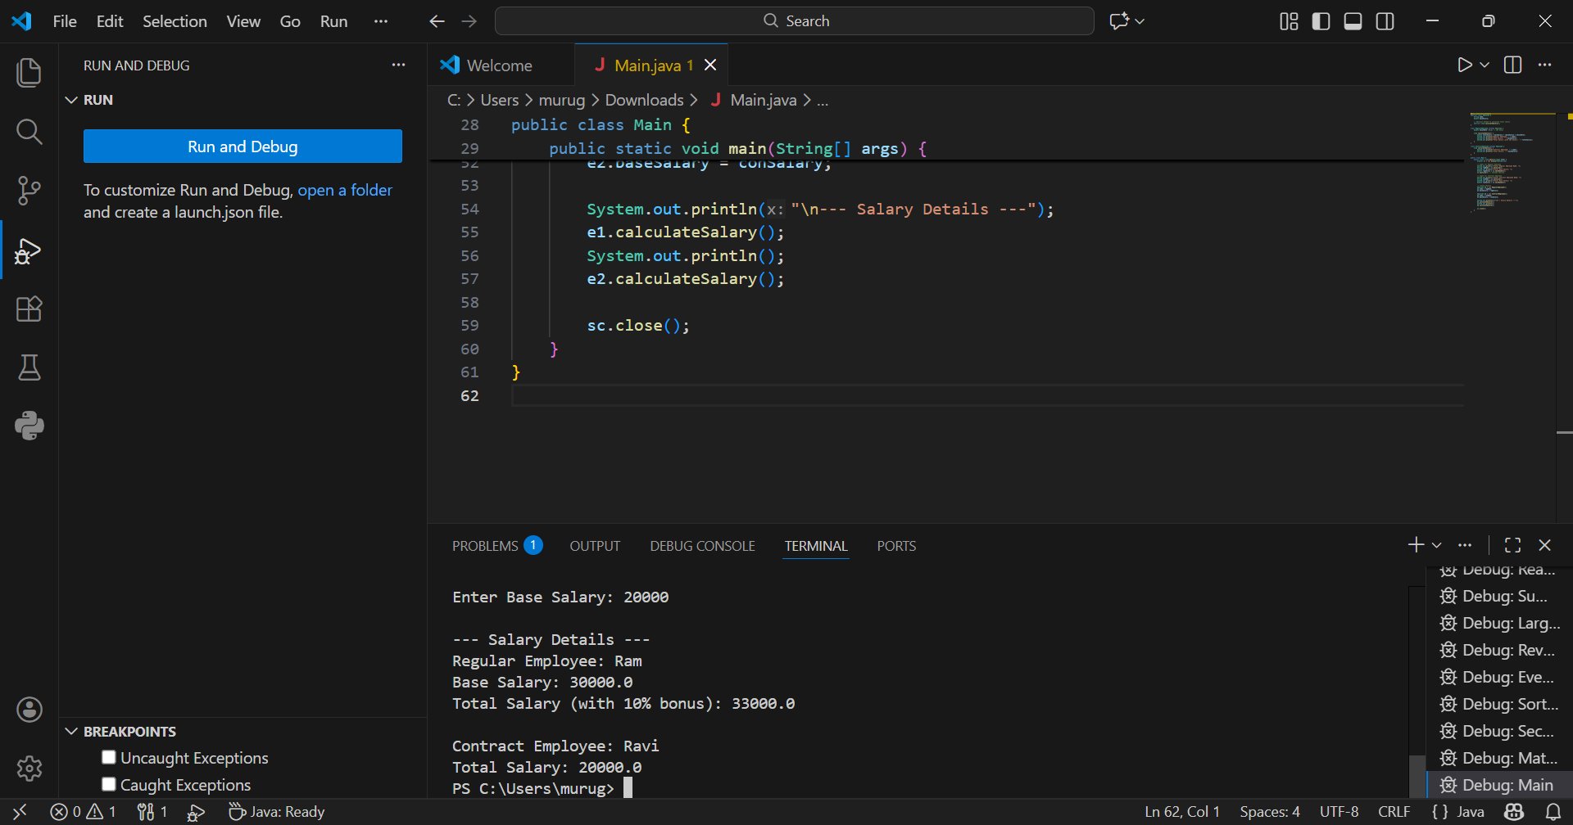
3.Banking System
Scenario:
A bank has different types of accounts: Savings and Current. Both accounts need a method to calculate interest, but the calculation differs for each account type.
Question:
Use an abstract class BankAccount with an abstract method calculateInterest() and implement it in SavingsAccount and CurrentAccount classes.
Code
abstract class BankAccount {
String accountHolder;
double balance;

BankAccount(String name, double bal) {
accountHolder = name;
balance = bal;
}

abstract void calculateInterest(); // Abstract method
}

class SavingsAccount extends BankAccount {
double interestRate = 0.04; // 4% interest

SavingsAccount(String name, double bal) {
super(name, bal);
}

void calculateInterest() {
double interest = balance * interestRate;
System.out.println("Savings Account Interest for " + accountHolder + " = " + interest);
}
}

class CurrentAccount extends BankAccount {
double interestRate = 0.02; // 2% interest

CurrentAccount(String name, double bal) {
super(name, bal);
}

void calculateInterest() {
double interest = balance * interestRate;
System.out.println("Current Account Interest for " + accountHolder + " = " + interest);
}
}

public class Main {
public static void main(String[] args) {
BankAccount acc1 = new SavingsAccount("Ram", 50000);
BankAccount acc2 = new CurrentAccount("Ravi", 80000);

acc1.calculateInterest();
acc2.calculateInterest();
}
}

Output
Savings Account Interest for Ram = 2000.0
Current Account Interest for Ravi = 1600.0
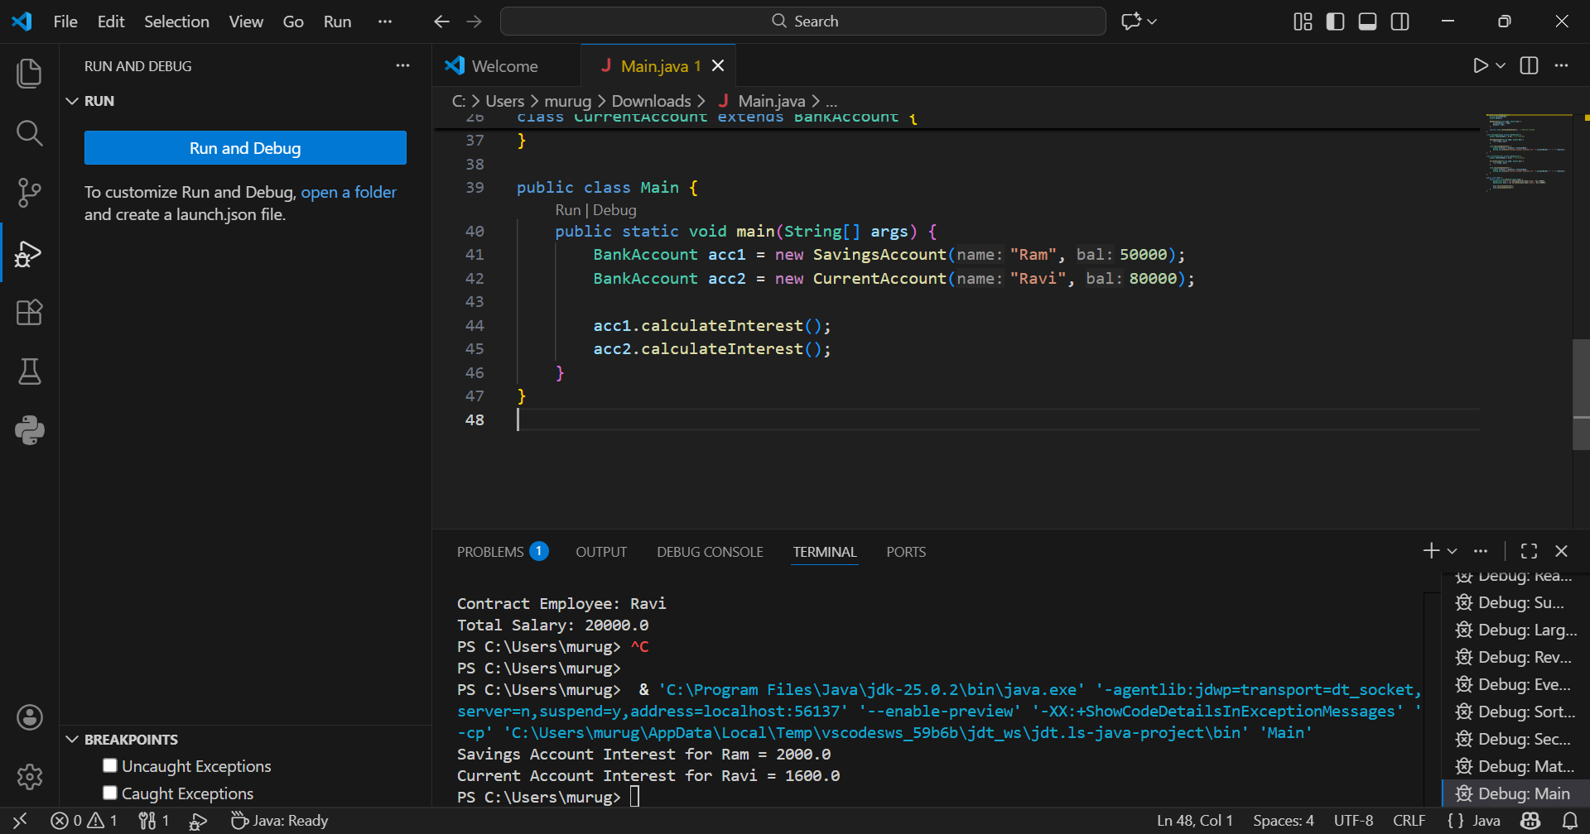
POST LAB EXERCISE
- How is an abstract class different from a regular class?
An abstract class cannot be instantiated and may contain abstract methods, while a regular class can be instantiated and must have complete method definitions.
- Can you create an object of an abstract class? Why or why not?
No, you cannot create an object of an abstract class because it may contain abstract methods that have no body, so it is incomplete.
- What happens if a subclass does not implement an abstract method?
If a subclass does not implement all abstract methods, then the subclass must also be declared abstract; otherwise, it results in a compile-time error.
- Can an abstract class exist without any abstract methods?
Yes, an abstract class can exist without abstract methods. It is used to prevent object creation and to provide a base for inheritance.
- Can an abstract class extend another abstract class?
Yes, an abstract class can extend another abstract class and inherit its abstract methods.
Result:

Thus the abstract classes and methods were implemented and executed successfully.

ASSESSMENT

Description | Max Marks | Marks Awarded
Pre Lab Exercise | 5
In Lab Exercise | 10
Post Lab Exercise | 5
Viva | 10
Total | 30
Faculty Signature

